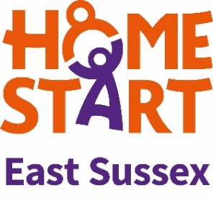
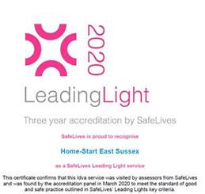
Home-Start East Sussex Intake Form
Independent Domestic Violence Support
The 1:1 IDVA support is available to Trans or non-binary people who have experienced any form of Domestic Abuse in the past, but are now away from the relationship and consider themselves safe.
Client Ref No: | Referral received by:
Intake date:  Repeat referral? | Self-referral ☐  How did you hear of the programme? |  |  | Professional referral ☐  Referred By  Name:  Job Title:  Agency:  Email:  Tel:  Please confirm:  Client is aware of the service ☐  Client consents to this referral ☐
Do you have sufficient mobile data/minutes or Wifi to access weekly Zoom meetings? Yes/No
Do you have a device that can use the Zoom software? Yes/No

Have you attended our programme before? Yes/No

Are you working with any other agencies/support services at the moment? Yes/No
If yes, please detail:

Please give a summary of historical and current relationship with perpetrator:

How long ago did the relationship end?
How long did the relationship last?

Abuse experienced: (Feel free to add further detail)
Psychological/mental: Y/N
Financial: Y/N
Sexual: Y/N
Physical: Y/N
Stalking/cyber-stalking: Y/N
Post separation abuse e.g. via child contact: Y/N

Do you feel safe at present? Y/N

Have you had more than one intimate partner who was a perpetrator? Yes/no
If yes, how many:
Client Information | Name:  Pronouns:
Date of birth: | Gender: | Gender assigned at birth:
Address:
Tel: |  | Email:
Preferred method of contact? |  | *Ethnicity:
*Religion: |  | *Sexuality: Please tick  Lesbian ☐ Gay ☐ Heterosexual/straight ☐ Bisexual ☐ Pansexual ☐ Asexual☐ Queer ☐ Prefer not to say ☐ Other (please specify) ☐
Primary language:
UK national? Y/N
Any immigration concerns?
Employment status (please give detail):

Relationship status:

If in a relationship,
Are you living with the person? Y/N
Do you feel safe with this person? Y/N
*Equality and diversity questions marked with an asterisk are optional. We are strongly committed to creating a safe space that is welcoming and inclusive of everyone within our services. The information below helps us to see where we could be doing better as an organisation. Please help us serve you and the community better by answering these questions, to the best of your ability.
Do you have a disability or difficulties with reading and writing? Yes/No
Please describe:
How can we best support you to get the best out of the Zoom group support?
Perpetrator Information | Are you still in contact with the perpetrator? Y/N  Are you experiencing post-separation abuse? Y/N  Any info below you have re. perpetrator is only necessary if you have had contact within the last three months.
Name/AKA: |  |  |  |  |  | Age:
Address:
Gender Identity: |  | Ethnicity:
Immigration issues:

Substance misuse or mental health issues including diagnosis and treatment:

Disability, literacy or numeracy difficulties:

Employment status and detail:

Could the perpetrator be a risk to you or the other women on the group if you attend the group? Yes/No
(e.g. staff safety issues, repeat perpetrator, suitable times to call client, honour-based violence, suicide/self-harm)

Children’s Information (UNDER 18) | Gender | DOB | Is perp their parent? |  | School
Name
Is client or partner pregnant? Yes/No | Due date and any other relevant info:
Living arrangements of children:

Contact arrangements with perpetrator:

Are your children likely to be at home on a weekday morning while you attend the programme? Yes/No

Do you have children/stepchildren over 18 living with you or at another address? Yes/No
If yes how many:

Children’s Services Involvement: Yes/No | How are they involved?
Do you have any concerns regarding children?

Email completed form to info@hses.org.uk

