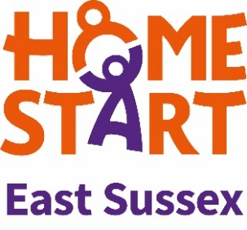
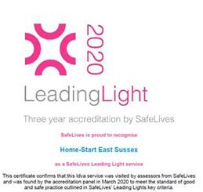
Home-Start East Sussex Intake Form
Who’s in Charge? Programme
The Who’s in Charge? programme is suitable for parents of children aged 8-18 whose behaviour is violent, abusive or seems out of control.
Client Ref No: | Programme Coordinator:
Intake date:  Repeat referral? | Self-referral ☐  How did you hear of the programme? |  |  | Professional referral ☐  Referred By  Name:  Job Title:  Agency:  Email:  Tel:  Please confirm:  Client is aware of the service ☐  Client consents to this referral ☐
Do you have sufficient mobile data/minutes or Wifi to access weekly Zoom meetings? Yes/No
Do you have a device that can use the Zoom software? Yes/No

Are you working with any other agencies/support services at the moment? Yes/No
If yes, please detail:

Abuse experienced: (Feel free to add further detail)

Name calling or aggressive language (verbal abuse) Yes/No
Manipulation or emotional abuse Yes/No
Destruction of property Yes/No
Physical abuse to parent Yes/No
Physical abuse to other family members Yes/No
Financial demands Yes/No

Have you got more than one child whose behaviour is violent? Yes/No
If yes, how many:

How long has this been going on for?

Please detail anything else you may have experienced or would like us to know:

Client Information | Name:  Pronouns:
Date of birth: | Gender: | Gender assigned at birth:
Address:
Tel: |  | Email:
Preferred method of contact? |  | *Ethnicity:
*Religion: |  | *Sexuality: Please tick  Lesbian ☐ Gay ☐ Heterosexual/straight ☐ Bisexual ☐ Pansexual ☐ Asexual☐ Queer ☐ Prefer not to say ☐ Other (please specify) ☐
Primary language:
UK national? Y/N
Any immigration concerns?
Employment status (please give detail):

Relationship status:

If in a relationship,
Are you living with the person? Y/N
Any concerns with domestic abuse? Y/N

*Equality and diversity questions marked with an asterisk are optional. We are strongly committed to creating a safe space that is welcoming and inclusive of everyone within our services. The information below helps us to see where we could be doing better as an organisation. Please help us serve you and the community better by answering these questions, to the best of your ability.
Children’s Information (UNDER 18) | Gender | DOB | School |  | Brief description of their behaviour, or the impact of their sibling’s behaviour on them
Name
Is client or partner pregnant? Yes/No | Due date and any other relevant info:
Living arrangements of children if different from your home address:

Are your children likely to be at home on a weekday morning while you attend the programme? Yes/No

Do you have children/stepchildren over 18 living with you or at another address? Yes/No
If yes how many:

Children’s Services Involvement: Yes/No | How are they involved?
Needs Assessment
Any yes answers, please detail.
Housing situation
Are you already receiving support? Yes/No
Do you need support? Yes/No
If so, please contact your local Housing Options Team https://www.southdown.org/how-we-help/housing-support/home-works-east-sussex

Financial situation
Are you already receiving support? Yes/No
Do you need support? Yes/No
If so, please contact your nearest Citizen’s Advice https://www.citizensadvice.org.uk/about-us/contact-us/contact-us/search-for-your-local-citizens-advice/

Alcohol or drug issues
Are you already receiving support? Yes/No
Do you need support? Yes/No
If so, please contact STAR https://www.changegrowlive.org/star-drug-alcohol-service-east-sussex

Mental health
Are you already receiving support? Yes/No
Do you need support? Yes/No
If so, please contact your GP or Health in Mind https://www.healthinmind.org.uk/

Physical health
Are you already receiving support? Yes/No
Do you need support? Yes/No
If so, please contact your GP

Immigration
Are you already receiving support? Yes/No
Do you need support? Yes/No
If so, please contact your nearest Citizen’s Advice https://www.citizensadvice.org.uk/about-us/contact-us/contact-us/search-for-your-local-citizens-advice/

Do you have a disability or difficulties with reading and writing? Yes/No
Please describe:
How can we best support you to get the best out of the Zoom group support?

Email completed form to info@hses.org.uk

