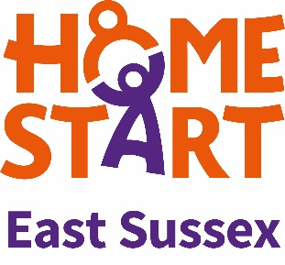
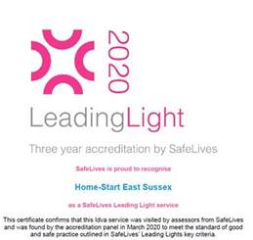
Guidance for Professionals
What does the HSES Lotus Domestic Abuse recovery programme cover?
Our six-week Programme supports and empowers women who are victims and survivors of domestic violence and abuse and who live in the East Sussex and Brighton & Hove area. The 6-weekly sessions are offered to women victim-survivors:
- who identify as any sexual orientation
- who are not in crisis so in “the right place”
- who have been assessed at standard risk (0-6 ticks on DASH) or possibly the lower end of medium risk (7-9 on DASH)
- whose primary need is for support is to recover after ending an abusive relationship, build confidence and help keep themselves and their children safe from future abusive relationships.
DURING THE COVID19 CRISIS AND THE NECESSITY FOR SOCIAL DISTANCING, THE APPROX 1.5 HR 6-WEEKLY PROGRAMME WILL BE DELIVERED VIA ZOOM.
The programme takes an experiential approach and covers:
- exploring the types of domestic abuse clients have experienced
- discussing and recognising the early warning signs
- managing anxiety
- the effects of domestic abuse of children
- parenting children who may be traumatised
- confidence-building
Until recently, our programmes were held in the community in places where people feel safe and we work closely with the other agencies to endure clients and their families are receiving the support they need.
“The changes to the group content demonstrate HSES’ commitment to continuous improvement and willingness to incorporate the feedback of their service users. After reflecting on the feedback of several group cycles, HSES chose to develop a bespoke group with hope and resiliency at the centre of it. The Lotus Programme incorporates opportunities for lots of different learning styles through quizzes, group discussions, group work, and PowerPoint presentations. The sessions allow for some flexibility on the day so that facilitators can tailor the approach to best meet the needs of the clients while still covering the main topic of the day. I witnessed this responsive, flexible approach during the group I observed where the facilitators took out an exercise that they felt would be too upsetting for the group to undertake at that time given the high level of emotional responses to the topic.” Leading Lights Assessment Report October 2019

What domestic abuse experience does HSES have?
Since 1996 the Home-Start East Sussex home-visiting service has been providing support to local families who have experienced domestic abuse in their past, or where crises have arisen and there is a need to refer to Refuge and other specialist services. We started delivering our specialist domestic abuse group-work programme in East Sussex and Brighton & Hove in 2016.
All HSES staff are well-qualified and experienced. Kate, the CEO of Home-Start East Sussex has a range of relevant postgraduate qualifications and has undertaken:
- SafeLives Domestic Abuse Service Managers Training
- Level 4 award in Skills for Service Managers Working in Gender Based Services
- Diploma in Domestic Violence Studies
- Certified Professional Freedom Facilitator
In addition, she is a member of the East Sussex County Council Local Safeguarding Children’s Board, the National Home-Start Federation Domestic Abuse Steering Group and the development committee for the East Sussex/Brighton & Hove joint strategy for Domestic Abuse and Sexual Violence and Violence Against Women and Girls.
Alex the Lotus Programme Facilitator has a Diploma in Domestic Violence Studies, is a certified Professional Freedom Facilitator and is PTLLS certified. She plans to work towards an IDVA qualification this year.
Rachel the Programmes Assistant has a BSc in Psychology with Clinical Approaches. She also has an MSc in Human Rights. She has completed the Freedom Programme and is working towards a Diploma in Domestic Violence Studies.

How do I know that the Lotus programme is a quality programme?
Home-Start East Sussex gained the nationally recognised SafeLives Leading Lights domestic abuse quality standards in February 2020 and The Lotus Programme was written in line with those standards. Leading Lights is an accreditation programme which recognises and rewards good and safe practice in community based domestic abuse services across the UK. The programme offers services, partner agencies and commissioners a set of standards for supporting victims of domestic abuse through a risk led response, and is designed to ensure that survivors of domestic violence receive the same level of service, regardless of where they are in the country.
The programme covers the core aspects of running a community based domestic abuse service – from case management to strategy and governance – offering guidance to the entire service team. Organisations demonstrate their commitment to supporting good and safe practice by meeting the Leading Lights standards which can be summarised in four main blocks: Governance; Human resources; Multi-agency working; Service provision.
“It was clear from the assessment that HSES have worked hard to ensure their service operates in line with the Leading Lights standards over the last year. They have designed the Lotus programme specifically around SafeLives Leading Lights standards.” SafeLives Assessor October 2019.
Eligibility
The HSES DA programme is for:
- women victim-survivors of domestic abuse - The programme is now gender-neutral so gay and bisexual women who have experienced abuse from a woman will find the programme relevant to them.
- those who consider themselves safe and would score 9 or under on a DASH risk assessment. (i) the perpetrator is no longer a risk to victim or other clients/staff attending the programme (ii) the victim is not dealing with any current crises and is at the right stage in their life to engage and benefit from the programme.
- aged 16+
- need support to enable them to move on from their experience of domestic abuse and keep themselves and their children safe in future relationships.
- Women with children of any age are prioritised and we promote the recovery of their children in line with our charity’s objectives. We aim to offer approx. 80% of places to women with children, some of whom might be subject to Child Protection plan, at risk of removal, living away from them e.g. they no longer have parental responsibility or their children are old enough to have left home
- We also accept referrals for women without children to whom we offer approx. 20% of the places.
- Not currently in crisis but are vulnerable as a result of their experience. Women on the bottom tier of Maslow’s Hierarchy of Needs will not be in ‘the right place’ to benefit from the programme.
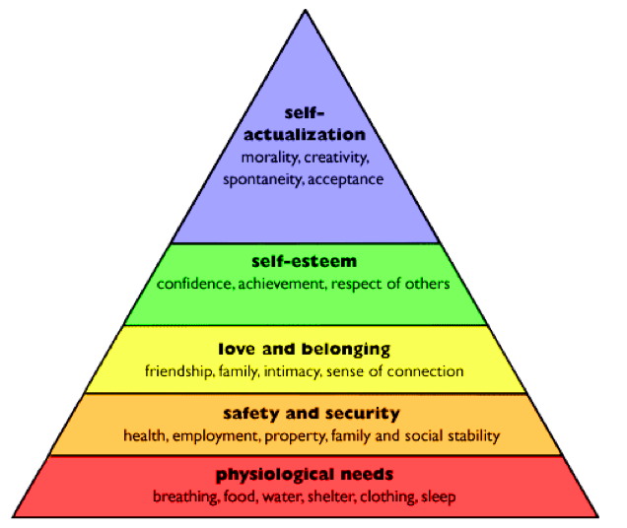
How do I make a referral?
Go to our website HSES.org.uk and click onto the Our Services the Lotus Domestic Abuse Recovery programme page. Download the Intake Form (as well as a DASH RIC if any abuse has taken place within the last three months.) The referrer must ensure that the service user has given consent for the referral. If the referral is missing key information we will return the referral to the referrer and won’t be able to accept it until it is completed. Email to info@hses.org.uk . Our email is secure but if your agency demands it, you can password protected the documents and confirm your name, agency and password to Alex by text 07505426118 or a separate email. Guidance can be found here https://www.wikihow.com/Password-Protect-a-Microsoft-Word-Document You will receive an automated email acknowledgement from the email address.
What happens next?
- Alex will assess and respond to all referrals according to risk.
- Referrals that prove not to be eligible will be returned to the referrer
- Rachel will aim to make first contact with clients within 5 working days of receiving all key information from referrer
- Once Alex makes contact with the client she will review any DASH submissions and talk to them about the programme.
- HSES staff will make three attempts to contact the client. If she is unable to make contact Rachel will let you know.
What then?
- If the client is eligible and decides to join a programme, she will be allocated to a specific programme or to our general waiting list depending on where/what residents our planned groups are for. Alex will talk to them about information sharing and support planning. Safety planning should not be necessary for eligible clients, unless their situation escalates after referral.
- When appropriate and subject to data protection, Alex may make contact with the referrer and other agencies regarding the safety of the client or their children.
- You can contact Alex, Programme Coordinator on 07505426118.
- To escalate a concern about the service you can contact the CEO kate.lawrence@hses.org.uk
Multi-Agency Working, Information Sharing and Confidentiality
- Where appropriate, and subject to Data Protection, Alex may make contact with the referrer and other agencies to liaise with them around the referral. You can also contact Alex if you have any questions. 07505426118.
- Service user data will be held securely and confidentially.
- There are safeguards to ensure that sensitive information is only accessed by those who ‘need to know’ about it.
- Where protective steps need to be taken, information may be shared with other agencies, such as the Police, Child or Adult Services.

“HSES provide a valuable service as part of the coordinated response to domestic abuse in East Sussex. The nature of their remit, however, means that they are often working with women long after the abuse or crisis has ended. In many circumstances they are the only organisation working with the client, which naturally limits the opportunities for demonstrating their multi-agency working. That being said, HSES remain part of the domestic abuse and safeguarding landscape in East Sussex in many other ways. When relevant, as observed in some of the case audits, the Community Idva will liaise with Children’s Social Care or refer into Marac when needed. The Chief Executive also participates in a number of strategic groups, such as LSCB, Brighton and Hove and East Sussex Partnership Domestic and Sexual Violence and Abuse and VAWG Strategy and Service Development Programme, and East Sussex Safeguarding Adults Board.

The organisation is committed to working with other agencies to promote, support and improve the response locally to victims of domestic abuse especially given the very limited time and funding they have to deliver the Lotus Programme.” Leading Lights Assessment Report October 2019

