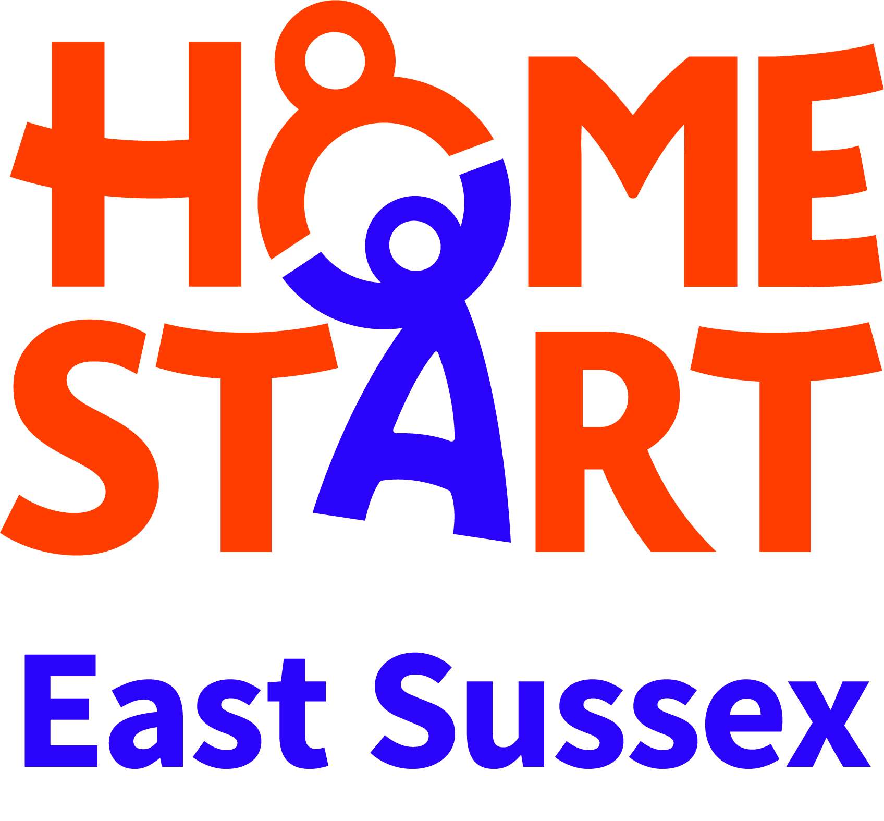
Guidance for Professionals
What does the HSES Lotus Domestic Abuse recovery programme cover?
Our six-week Programme supports women who are victims and survivors of domestic violence and abuse and who live in the East Sussex and Brighton & Hove area. The service is offered one day a week to women who are not in crisis, have been assessed at standard risk (0-6 ticks on DASH) or possibly the lower end of medium risk (7-9 on DASH)and their primary need is for support is to recover after ending an abusive relationship and help keep themselves and their children safe from future abusive relationships.
The programme takes an experiential approach and covers:
- exploring the types of domestic abuse clients have experienced
- discussing and recognising the early warning signs
- managing anxiety
- the effects of domestic abuse of children
- parenting children who may be traumatised
- confidence-building
Our programmes are held in the community in places where people feel safe and we work closely with the other agencies to endure clients and their families are receiving the support they need.
What domestic abuse experience does HSES have?
Since 1996 the Home-Start East Sussex home-visiting service has been providing support to local families who have experienced domestic abuse in their past, or where crises have arisen and there is a need to refer to Refuge and other specialist services. We started delivering our specialist domestic abuse group-work programme in East Sussex and Brighton & Hove in 2016.
All HSES staff are well-qualified and experienced. Kate, the CEO of Home-Start East Sussex has a range of relevant postgraduate qualifications and has undertaken SafeLives Domestic Abuse Service Managers Training. She has a level 4 award in Skills for Service Managers Working in Gender Based Services. In addition, she is a member of the East Sussex County Council Local Safeguarding Children’s Board, the National Home-Start Federation Domestic Abuse Steering Group and the development committee for the East Sussex/Brighton & Hove joint strategy for Domestic Abuse and Sexual Violence and Violence Against Women and Girls.
Vicki, the Co-ordinator of the Lotus Programme (our Community IDVA) works 20 hours a week. She is a qualified SafeLives IDVA (Independent Domestic Violence Adviser). This level 4 training is aimed at those working with High Risk Clients – a higher level of risk than those eligible for our programme.
Vicki is a certified Professional Freedom Facilitator and a former probation officer where she spent 8 year’s working with male and female victims and perpetrators of abuse. She was a court officer and ran group-work programmes for offenders.
Alex the Programme Assistant is a certified Professional Freedom Facilitator and has undertaken other domestic abuse training to fit her for assisting at the weekly sessions. She has a Diploma in Domestic Violence Studies.

How do I know that the Lotus programme is a quality programme?
The Lotus Programme was written to meet the SafeLives Leading Lights quality standards. Leading Lights is an accreditation programme which recognises and rewards good and safe practice in community based domestic abuse services across the UK. The programme offers services, partner agencies and commissioners a set of standards for supporting victims of domestic abuse through a risk led response, and is designed to ensure that survivors of domestic violence receive the same level of service, regardless of where they are in the country.
The programme covers the core aspects of running a community based domestic abuse service – from case management to strategy and governance – offering guidance to the entire service team. Organisations demonstrate their commitment to supporting good and safe practice by meeting the Leading Lights standards which can be summarised in four main blocks:
• Governance
• Human resources
• Multi-agency working
• Service provision
“It was clear from the assessment that HSES have worked hard to ensure their service operates in line with the Leading Lights standards over the last year. They have designed the Lotus programme specifically around SafeLives Leading Lights standards and in the majority of areas they have met the standard required with 9 standards that require further evidence to show they are embedded in practice.” SafeLives Assessor October 2019. These 9 standards will be re-assessed in February 2020.
Eligibility
The HSES DA programme is for:
- women victim-survivors of domestic abuse
- those who consider themselves safe and would score 9 or under on a DASH risk assessment. (i) the perpetrator is no longer a risk to victim or other clients/staff attending the programme (ii) the victim is not dealing with any current crises and is at the right stage in their life to engage and benefit from the programme.
- aged 16+
- need support to enable them to move on from their experience of domestic abuse and keep themselves and their children safe in future relationships.
- not currently in crisis but are vulnerable as a result of their experience.
- Women with children of any age are prioritised and we promote the recovery of their children in line with our charity’s objectives. We aim to offer approx. 80% of places to women with children, some of whom might be subject to Child Protection plan, at risk of removal, living away from them e.g. they no longer have parental responsibility or their children are old enough to have left home
- We also accept referrals for women without children to whom we offer approx. 20% of the places.
How do I make a referral?
Go to our website HSES.org.uk and click onto the Our Services the Lotus Domestic Abuse Recovery programme page. Download the Intake Form (as well as a DASH RIC if any abuse has taken place within the last three months.) The referrer must ensure that the service user has given consent for the referral. If the referral is missing key information we will return the referral to the referrer and won’t be able to accept it until it is completed. Email to vicki.thomson@hses.org.uk . Our email is secure but if your agency demands it, you can password protected the documents and confirm your name, agency and password with Vicki by text 07505426118 or a separate email. Guidance can be found here https://www.wikihow.com/Password-Protect-a-Microsoft-Word-Document You will receive an automated email acknowledgement from Vicki’s email address.
What happens next?
- Vicki will assess and respond to all referrals according to risk.
- Referrals that prove not to be eligible will be returned to the referrer
- Vicki will aim to make first contact with clients within 5 working days of receiving all key information from referrer
- Once Vicki makes contact with the client she will review any DASH submissions and talk to them about the programme.
- She will make three attempts to contact the client. If she is unable to make contact Vicki will let you know.
What then?
- If the client is eligible and decides to join a programme, she will be allocated to a specific programme or to our general waiting list depending on whether there is a programme planned in their area. Vicki will talk to them about information sharing and support planning. Safety planning should not be necessary for eligible clients, unless their situation escalates after referral.
- When appropriate and subject to data protection, Vicki may make contact with the referrer and other agencies regarding the safety of the client or their children.
- You can contact Vicki, Community IDVA and Programme Coordinator on 07505426118.
- To escalate a concern about the service you can contact the CEO kate.lawrence@hses.org.uk
Information Sharing and Confidentiality
- Where appropriate, and subject to Data Protection, Vicki may make contact with the referrer and other agencies to liaise with them around the referral. You can also contact Vicki if you have any questions. 07505426118.
- Service user data will be held securely and confidentially.
- There are safeguards to ensure that sensitive information is only accessed by those who ‘need to know’ about it.
- Where protective steps need to be taken, information may be shared with other agencies, such as the Police, Child or Adult Services.

