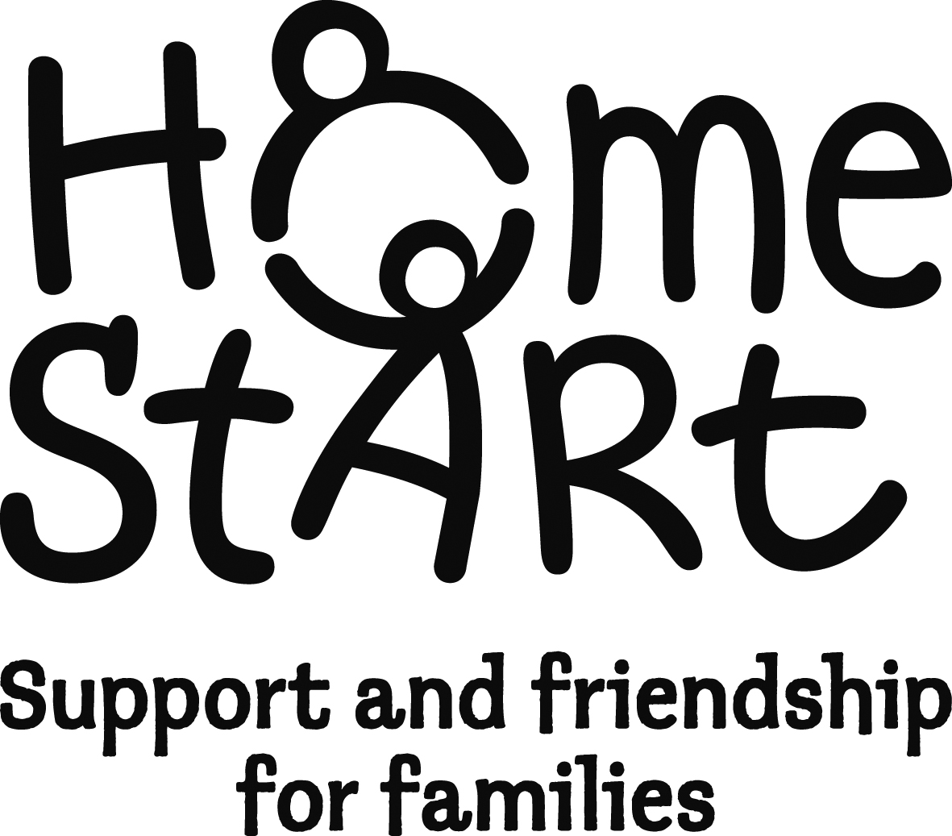
Job Description & Person Specification
Deadline for applications: 28th August
Interview dates: 4, 5 or 6th September
Note: if you are shortlisted you will be asked to deliver a 5 minute presentation: What are the key components of a strengths-based approach to domestic abuse services?

Job Title | Community IDVA
Reports to | Chief Executive
Purpose of Job | Delivering the Freedom course, assessing, supporting and empowering women-survivors of domestic violence, working in partnership with other agencies.  Providing a high quality frontline information service to women attending the course.  Contribute to the overall operation of Home-Start East Sussex  The successful candidate will have extensive experience of delivering domestic abuse interventions and will be passionate and proactive about meeting the needs of women-survivors and their families. She will have an excellent understanding of domestic abuse in the context of power and control and will strive to achieve the best outcomes for the women attending the Freedom course (and their children), helping them to recover from their experiences and live fulfilling lives.  Taking a strength-based approach to your work, you will be skilled in safety planning, risk assessment and risk management. You will be compassionate, tenacious, with a strong commitment to ensuring their safety. You will be organised, computer literate and able to build successful partnerships with key partners, in order to improve outcomes for your clients.
Pay Scale | 26 -32 £23,866 to £29,055 pro rata
Hours per week | 20 – some flexibility around courses
Work Base | Post involves a lot of travel. Courses are held across East Sussex and Brighton & Hove. Office is in Newhaven but as our computer system is cloud based, can also work from home.

Key Activities
- To take the lead in the development and delivery of the Freedom courses across East Sussex and Brighton & Hove in accordance with standards and targets.
- To offer training, interventions and strategies to our service-users to effect positive change, including referrals and signposting.
- To promote the work of the project/HSES with other organisations.
- To engage, support, advocate and provide relevant information to domestic abuse victim-survivors. Provide support to bring about life changes, improved health and reduced risk.
- To undertake initial assessments, implement risk assessments, DASH RIC, safety planning and risk management.
- Provide appropriate support in between course days through meaningful telephone contact.
- To keep abreast of relevant developments in service and legislation.
- To ensure the implementation of all HSES’s policies including those relating to Safeguarding Children and Adults at Risk.
- To achieve a balance between the demands of the developmental and the delivery aspects of the role
- To adhere to the current process, procedures and policies and maintain satisfactory records of the work undertaken with service-users. Store records and information appropriately and in accordance with HSES policies.
- To reflect on own and others’ practice through supervision.
- To work flexibly and effectively with colleagues to ensure seamless delivery of service.
- To work closely with statutory and voluntary agencies and develop and maintain effective multi-agency joint working approaches.
- To ensure the targets and aims of the project are met and that the highest possible professional standards underpin the work.
- To maintain operational systems as required and provide any necessary data /information outputs and reports in a timely and professional manner.
- To follow safeguarding processes and statutory authority child protection procedures and protection of adults at risk, at all times.
- To work flexibly within the agreed number of hours to maintain levels of service provision.
- With the Chief Executive, review the service provision regularly and as required. Attend training as required. Cover the work of other staff during holiday and sickness absence.

Person specification
Training, Knowledge and Skills | Mandatory/  Discretionary
Substantial experience of direct work with people who have experienced domestic abuse including carrying out DASH Assessments and advising on safety plans and risk minimisation  An understanding of the strengths and limitations of the Deluth Model  Experience of supporting people to use Non Violent Communication and/or Non Violent Resistance | M (2 points)  M (2 point)  D (1 point)
At least one Mandatory:  holds a Safelives IDVA training certificate  or willing to work towards | (2 points) or  (1 point)
At least one Manadatory:  Has attended Freedom Facilitator Training  Or willing to work attend three day professional facilitator course  Other relevant level 4 qualification | (2 points) or  (1 point)  D (1 point)
Experience of court, civil and criminal justice systems. | D (1 point)
An understanding of the issues affecting people who are or have experienced domestic abuse and the impact on their health and the health of their born or unborn children. The legislative framework that surrounds these issues. | M (2 points)
Demonstrable empowering, strengths-based , solution-focused approach to working with victim-survivors | M (2 points)
Ability to build and maintain professional partnerships | M (2 points
Ability to engage with people of diverse backgrounds. | M (2 points)
Sensitivity and kindness when working with people with complex issues. | M (2 points)
Ability to maintain a practical, positive and considered approach when dealing with challenging behaviour | M (2 points)
Self-motivated and competent at organising own workload with a flexible and resilient attitude. | M (2 points)
Willingness and ability to undertake training relevant to the current post and future related work | M (2 points)
Demonstrable safe working knowledge and practice of safeguarding - Child Protection and Adults at Risk | M (2 points)
Good organisational abilities, excellent written and verbal communication, negotiation and advisory skills | M (2 points)
computer literate (especially Word, Outlook and Excel) and positive attitude to embrace new technology  Working experience of Microsoft 365 including shared drive | M (2 points)  D (1 point)
Ability in and experience of recording data for monitoring purposes – compiling internal/external reports as required and meeting deadlines. | M (2 points)
Ability to work independently and in a team. | M (2 points)
Ability to travel extensively across East Sussex and Brighton & Hove. | M (2 points)
Ability and commitment to work collaboratively with the Chief Executive and other staff regarding ongoing improvements to the service and charity | M (2 Points)
Must be female | M (2 Points)

This post is subject to a DBS check at an enhanced level.
This description accurately reflects the current position. It may be amended or reviewed.

