Autumn Newsletter 2016
Thank you to all our wonderful volunteers who home-visited 92 families from April until the end of October.
As you may know, we are currently developing and delivering a pilot project. The Home-Start Freedom Domestic Abuse programme is a three month course that will run in Eastbourne and Hastings in January 2017. It is for women who are interested in finding out more about the reality of domestic abuse, whether they are in or have left a domestic abuse relationship, including women who have no plans to leave their partner. In October we held two information events in Hastings and Eastbourne for potential referrers and they were a real success. The courses will start in January and places are filling up nicely. If you know anyone who has experience of domestic abuse, please encourage them to contact us so we can save them a place. Sarah’s number is 07505 426118
Sarah is managing the volunteer home-visiting service to fragile families in areas where we are currently receiving financial support – at the moment this is Wealden and certain areas within Hastings and Rother, although this is subject to change. Inevitably the service has reduced significantly but we are determined to build it back up again as we receive funding successes.
This year our priority has been to reduce expenditure and secure funds to enable our home-visiting support to vulnerable families to continue for the longer term. We have been taking a two-pronged long-term and short-term approach to fundraising. We now have enough money to keep us going until the end of March 2017 and we have reached Stage Two of a couple of significant multiyear funding streams, which is promising.
For more information contact info@hses.org.uk or 01273 612025
Kind regards
Kate Lawrence
Chief Executive

Whilst I was looking for a healthy recipe to share with you this quarter, I came across this delicious, healthy and quick breakfast which is meant to be for young children but my teenagers love it and so do I!
Banana and Peanut Butter Tortilla Roll-ups – open out a wholemeal tortilla wrap, spread liberally with peanut butter (I use a sugar free brand), peel a banana and lay it down the middle then roll up the wrap around the banana, folding in the ends to keep it in place.
ww.eatsamazing.co.uk.

Did you know that whenever you buy anything online - from your weekly shop to your annual holiday - you could be collecting free donations for Home-Start East Sussex?
There are over 3,000 shops and sites on board ready to make a donation, including Amazon, John Lewis, Aviva, thetrainline and Sainsbury's – it doesn't cost you a penny extra!
It's as easy as 1, 2, 3...
1. Head to https://www.easyfundraising.org.uk/causes/homestarteastsussex/ and join for free.
2. Every time you shop online, go to easyfundraising first to find the site you want and start shopping.
3. After you’ve checked out, that retailer will make a donation to your good cause for no extra cost whatsoever!
There are no catches or hidden charges and Home-Start East Sussex will be really grateful for your donations.
Thank you for your support

STOP

This a support group for parents of older children (10-16) run at the Downs Farm Community Centre in Hastings, supported by Amicus Horizon
A FREE friendly and relaxed ten week group covers: strengthening relationships, not getting sucked into arguments, getting them to listen, effective communication and much more. Meet with other parents week by week and share ideas and experiences.
For more information or to book a place call Alex on 01424 725800 or text STOP to 07595777764

Community Navigator Service in Peacehaven
Peacehaven Children Centre have a "Community Navigator Service" every Monday between 9.30 am and 1.30 pm held at the Peacehaven Children's Centre. Appointments can be made in advance for one hour. If you would like an appointment to see someone for help with any problems you may be facing in any area of your life. The service can refer you to advice services for advice on benefits, debt, housing or money management and also link you in with a wide range of other specialised services and activities Please call 01273 335100 to book your appointment.
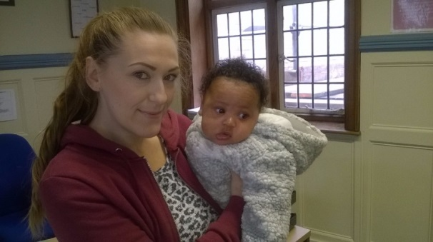

Congratulations Kim!
We are delighted to announce that Kim, our administrator had a healthy baby boy. Both Kim and Isaiah are doing really well. Here they are at Isaiah's first visit to the office

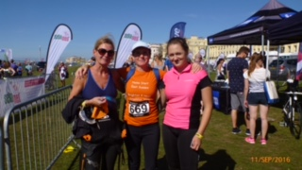

Thank you!
Thank you very much to Abbi, Issy and Justine who completed the Brighton triathlon in September to raise money for Home-Start East Sussex. So far they have raised £445 and would love to get to their target of £500. You can still make a donation by following this link https://mydonate.bt.com/fundraisers/abi1

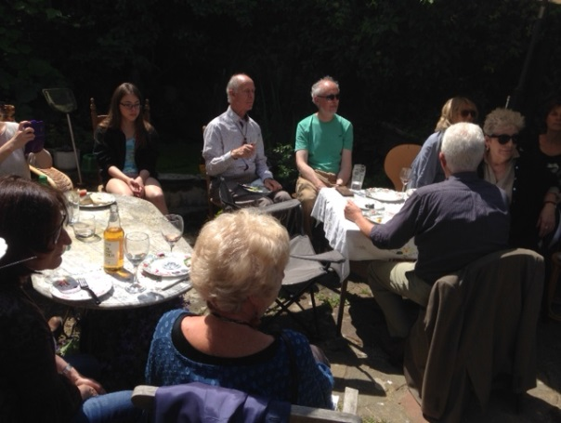

More thanks to....
Jane Ratcliffe, HM Carpenter, Deirdre O’Connell, P & S Baker, G Hermer and Bexhill Rotary for their generous donations.
Also huge thanks to Maxine Toff for organising her annual Bagel Bash which was possibly the best ever.
And finally to Issy and Tom who not only entertained the children at our lunch to celebrate our volunteers, but also donated their holiday money!

