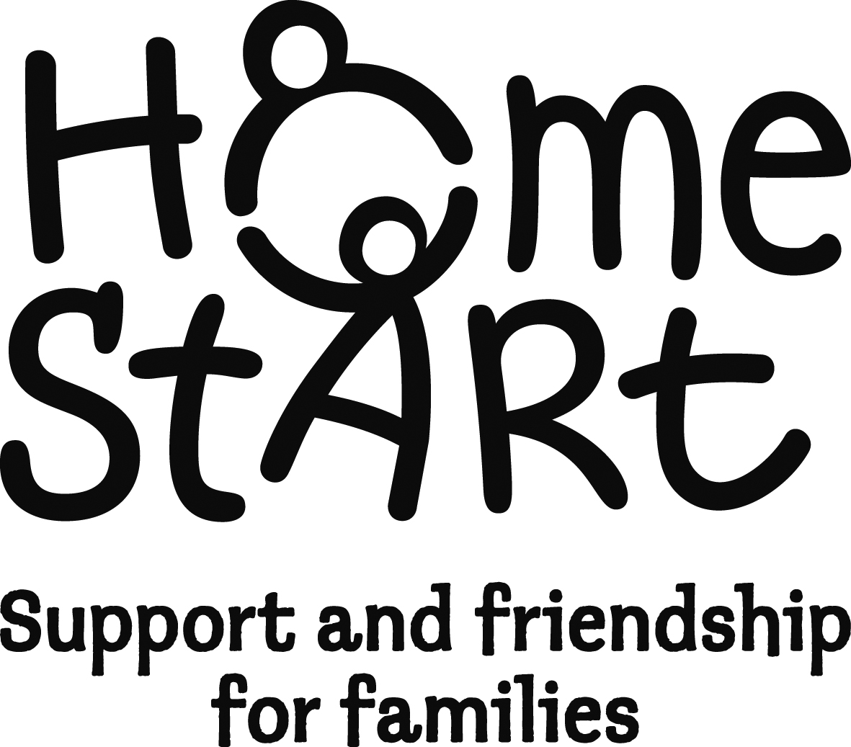
Referral form Date referral received (scheme use) ___________Family No ______

Please send completed referral forms to: info@HSES.org.uk
Home-Start East Sussex, 30A High Street, Newhaven. BN9 9PD 01273 612025

Before you refer, please ensure that you are able to answer 'yes' to these questions

- Have you discussed this referral with the family prior to completing this form?
- Does the family have at least one child under the age of five years or pregnant?
- Is the family an overall level 2 on the Continuum of Need?
- Have you identified one or two realistic objectives that can be met within 8 weeks of support?

Name of family…………………………………………………………………………….…..………………..
Address……………………………………………………………………………………………………………
………………………………………………………………Postcode …………………………………………
Tel. No …………………………Mobile No …………………..………E mail ………………………………

Please provide some details about the adults caring for the child[ren]:
 | Name | Main carer √ | Resident in household√ | Comments
Mother/partner
Father/partner
Other main carer[s]
Other main carer[s]

Was this referral generated by a TAF meeting?

Was this referral made as a result of a discussion between a Health Visitor and Keyworker?

Name  Role  Agency  Address  E mail  Tel | Date of referral: Click here to enter a date.  Other agencies involved:

Please check all that apply to this family:

Lone Parent ☐ Substance abuse ☐ Domestic abuse ☐ Mental health issues ☐
Learning disabilities ☐ Post natal depression ☐ Interpreter req’d ☐ Teenage pregnancy ☐
Other (please specify) ☐ ………………………………………………………………………………………………………………
Are there any Health and Safety issues that we need to consider when placing a volunteer with this family: ………………………………………………………………………………………………………………
………………………………………………………………………………………………………………………………
Please add any background information that you think we would find useful (if necessary attach an extra sheet)…………………………………………………………………………………………………
………………………………………………………………………………………………………………………………

Details of children - Please note the family must have at least one child under the age of five years, (please include details of all children under 18)
Child’s name Sex Date of Dis- Subject to Child Ethnic
Eldest first Birth abled? CAF/Early in Group
M / F Help Plan Need?
C1._____________________________ ☐ / ☐ __________ ☐ ☐ ☐ Choose an item.
C2._____________________________ ☐ / ☐ __________ ☐ ☐ ☐ Choose an item.
C3._____________________________ ☐ / ☐ __________ ☐ ☐ ☐ Choose an item.
C4._____________________________ ☐ / ☐ __________ ☐ ☐ ☐ Choose an item.
C5._____________________________ ☐ / ☐ __________ ☐ ☐ ☐ Choose an item.

Please complete the following Early Help Info, using Continuum of Need Scores

Has the family agreed to share their Early Help Plan? ☐
Overall Continuum of Need Level: Choose an item.

Details of other members of the household with responsibilities for caring for the children
Gender Date of Immigration Disabled Ethnic
Birth Status Group
Main Carer Choose an item. Choose an item. ☐ Choose an item.
Partner living Choose an item. Choose an item. ☐ Choose an item.
in household

Referrer’s signature ……………………………………….. Date …Click here to enter a date.

Parent’s signature …………………………………………. Date …Click here to enter a date. (optional)

If this form is being sent by email, please tick this box

Thank you for taking time to provide this information which will help us to process the referral.

We are unable to process your referral until we have received this form
We will try to respond to you within two weeks to tell you about progress with this referral. We usually accept all appropriate referrals, but if we do not have the resources to support a family immediately we will let you know and keep you informed on a monthly basis.

We will remain in touch while supporting this family and will contact you when the support ends
If you have any issues or concerns about the referral process or about the support a family is receiving from HSES, please contact the Scheme Manager: Kate Lawrence, kate.lawrence@HSES.org.uk.
Please send completed referral forms to info@HSES.org.uk

